ANGULAR - HANDS-ON

EXERCISE 1: Environment Setup, Project Structure & First Component
CODE:
notes.txt:
- angular.json - Workspace-wide build/serve/test configuration (builders, budgets, file paths).
- tsconfig.json - Base TypeScript compiler options shared by app and tests.
- tsconfig.app.json - TypeScript config specifically for building the browser app.
- package.json - npm dependencies, devDependencies, and CLI scripts (start/build/test).
- src/main.ts - Application entry point; bootstraps the standalone AppComponent with appConfig.
- src/app/app.config.ts - Root application providers (router, HttpClient, NgRx store) - replaces app.module.ts in standalone Angular.
- src/app/app.component.ts - Root component; hosts the header and <router-outlet> for all pages.
- src/index.html - The single HTML page host; Angular bootstraps into <app-root> here.

app.component.html:
<app-header></app-header>
<main>
<router-outlet></router-outlet>
</main>

components/header/header.component.ts:
import { Component } from '@angular/core';
import { RouterLink } from '@angular/router';

// HANDS-ON 1 Task 2 Step 6-7
@Component({
selector: 'app-header',
standalone: true,
imports: [RouterLink],
templateUrl: './header.component.html',
styleUrls: ['./header.component.css'],
})
export class HeaderComponent {}

components/header/header.component.html:
<nav>
<span class="brand">Student Course Portal</span>
<a routerLink="/">Home</a>
<a routerLink="/courses">Courses</a>
<a routerLink="/profile">Profile</a>
</nav>

pages/home/home.component.html:
<h1>Student Course Portal</h1>
<p>Welcome back! Browse your courses, track grades, and manage enrollment all in one place.</p>
<div class="stats">
<span>Courses Available: 12</span>
<span>Enrolled: 3</span>
<span>GPA: 3.8</span>
</div>

OUTPUT:
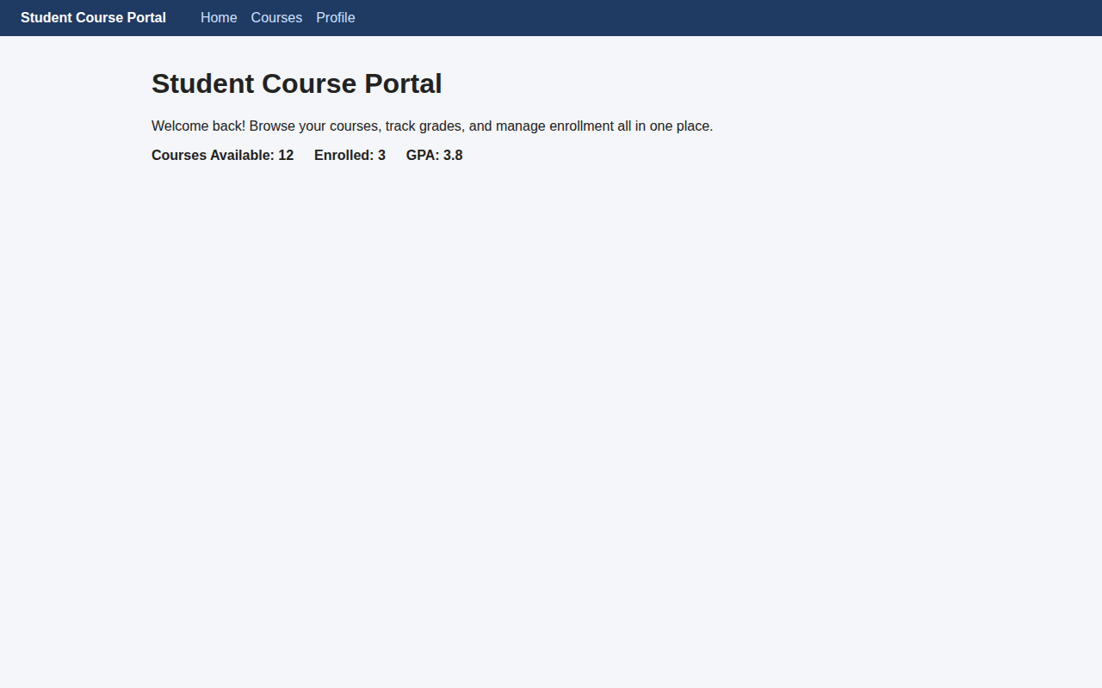

EXERCISE 2: Data Binding, Lifecycle Hooks & Component Communication
CODE:
pages/home/home.component.ts:
import { Component, OnDestroy, OnInit } from '@angular/core';
import { CommonModule } from '@angular/common';
import { FormsModule } from '@angular/forms';

// HANDS-ON 2 Task 1 & 2: all 4 binding types + lifecycle hooks
@Component({
selector: 'app-home',
standalone: true,
imports: [CommonModule, FormsModule],
templateUrl: './home.component.html',
styleUrls: ['./home.component.css'],
})
export class HomeComponent implements OnInit, OnDestroy {
portalName = 'Student Course Portal';
isPortalActive = true;
message = '';
searchTerm = '';

ngOnInit(): void {
console.log('HomeComponent initialised - courses loaded');
}

ngOnDestroy(): void {
console.log('HomeComponent destroyed');
}

onEnrollClick(): void {
this.message = 'Enrollment opened!';
}
}

pages/home/home.component.html
<h1>{{ portalName }}</h1>
<p>Welcome back! Browse your courses, track grades, and manage enrollment all in one place.</p>

<div class="stats">
<span>Courses Available: 12</span>
<span>Enrolled: 3</span>
<span>GPA: 3.8</span>
</div>

<button [disabled]="!isPortalActive" (click)="onEnrollClick()">Enroll Now</button>
<p *ngIf="message">{{ message }}</p>

<input [(ngModel)]="searchTerm" placeholder="Search courses..." />
<p>Searching for: {{ searchTerm }}</p>

components/course-card/course-card.component.ts:
import { Component, EventEmitter, Input, OnChanges, OnInit, Output, SimpleChanges } from '@angular/core';

export interface Course {
id: number; name: string; code: string; credits: number; gradeStatus: 'passed' | 'failed' | 'pending';
}
@Component({
selector: 'app-course-card',
standalone: true,
templateUrl: './course-card.component.html',
styleUrls: ['./course-card.component.css'],
})
export class CourseCardComponent implements OnInit, OnChanges {
@Input() course!: Course;
@Output() enrollRequested = new EventEmitter<number>();

ngOnInit(): void {
console.log('CourseCardComponent initialised for', this.course?.name);
}

ngOnChanges(changes: SimpleChanges): void {
if (changes['course']) {
console.log('course changed:', changes['course'].previousValue, '->', changes['course'].currentValue);
}
}

onEnroll(): void {
this.enrollRequested.emit(this.course.id);
}
}

pages/course-list/course-list.component.ts:
import { Component } from '@angular/core';
import { CommonModule } from '@angular/common';
import { CourseCardComponent, Course } from '../../components/course-card/course-card.component';
@Component({
selector: 'app-course-list',
standalone: true,
imports: [CommonModule, CourseCardComponent],
templateUrl: './course-list.component.html',
})
export class CourseListComponent {
courses: Course[] = [
{ id: 1, name: 'Data Structures', code: 'CS101', credits: 4, gradeStatus: 'passed' },
{ id: 2, name: 'Operating Systems', code: 'CS102', credits: 4, gradeStatus: 'pending' },
{ id: 3, name: 'Database Systems', code: 'CS103', credits: 3, gradeStatus: 'failed' },
{ id: 4, name: 'Computer Networks', code: 'CS104', credits: 3, gradeStatus: 'pending' },
{ id: 5, name: 'Web Technologies', code: 'CS105', credits: 2, gradeStatus: 'passed' },
];
selectedCourseId: number | null = null;

onEnroll(courseId: number): void {
console.log('Enrolling in course:', courseId);
this.selectedCourseId = courseId;
}
}

OUTPUT:
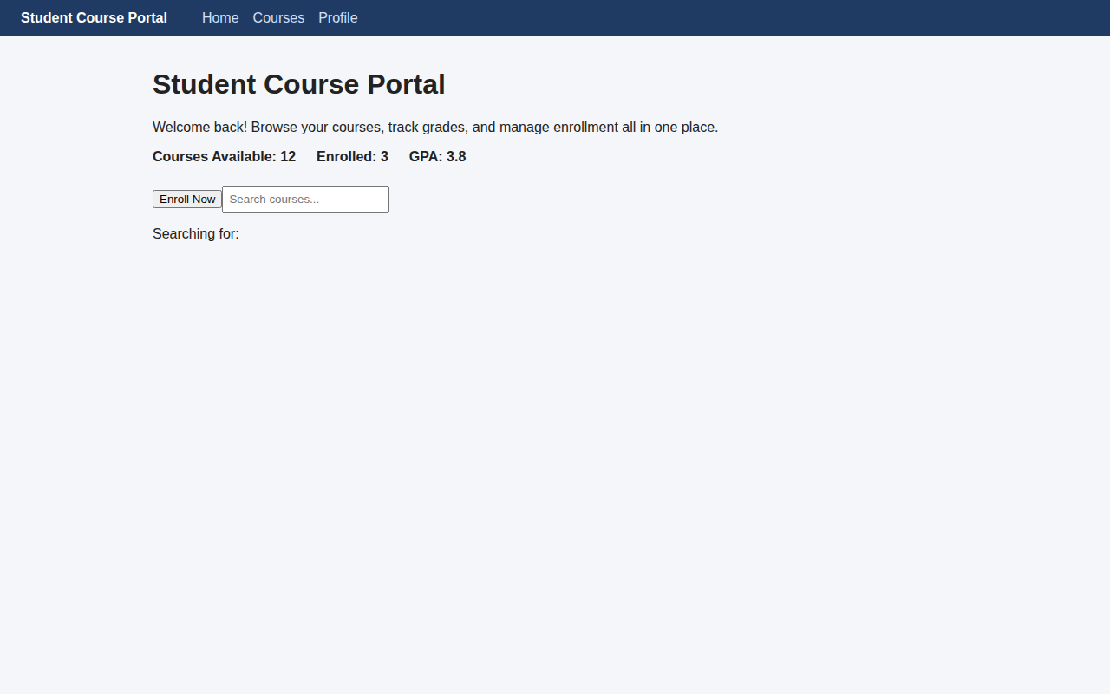
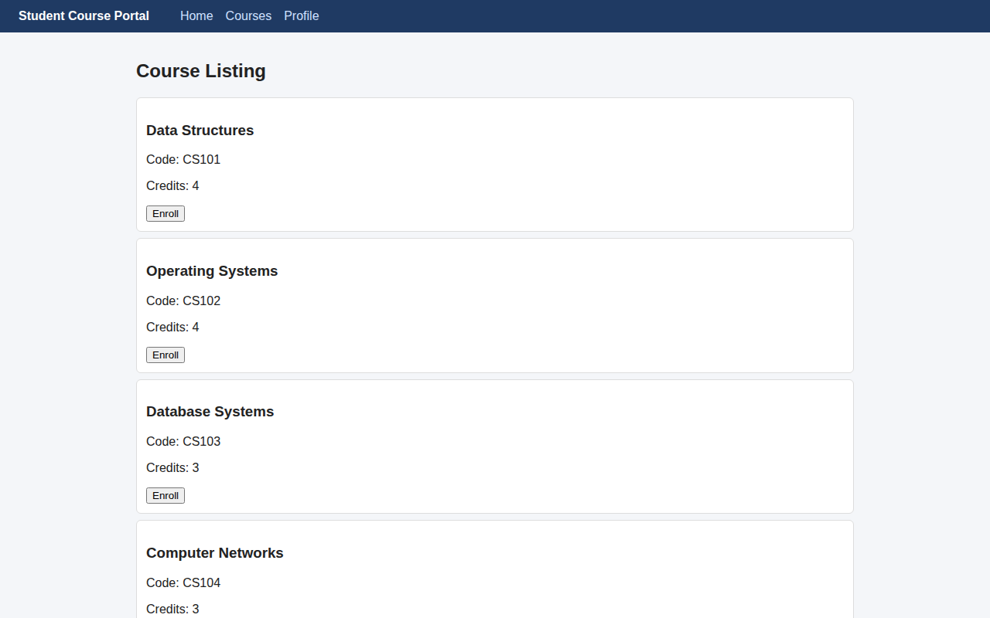
Course list - @Input/@Output parent-child communication (http://localhost:4202/courses)

EXERCISE 3: Directives & Pipes - Built-in and Custom
CODE:
directives/highlight.directive.ts:
import { Directive, HostListener, Input, ElementRef } from '@angular/core';
@Directive({ selector: '[appHighlight]', standalone: true })
export class HighlightDirective {
@Input() appHighlight = 'yellow';
constructor(private el: ElementRef<HTMLElement>) {}

@HostListener('mouseenter') onEnter(): void {
this.el.nativeElement.style.backgroundColor = this.appHighlight || 'yellow';
}
@HostListener('mouseleave') onLeave(): void {
this.el.nativeElement.style.backgroundColor = '';
}
}

pipes/credit-label.pipe.ts:
import { Pipe, PipeTransform } from '@angular/core';

@Pipe({ name: 'creditLabel', standalone: true })
export class CreditLabelPipe implements PipeTransform {
transform(credits: number | null | undefined): string {
if (credits === null || credits === undefined || credits === 0) return 'No Credits';
return credits === 1 ? '1 Credit' : `${credits} Credits`;
}
}

components/course-card/course-card.component.ts:
import { Component, EventEmitter, Input, OnChanges, OnInit, Output, SimpleChanges } from '@angular/core';
import { CommonModule } from '@angular/common';
import { CreditLabelPipe } from '../../pipes/credit-label.pipe';
import { HighlightDirective } from '../../directives/highlight.directive';

export interface Course {
id: number; name: string; code: string; credits: number; gradeStatus: 'passed' | 'failed' | 'pending';
}

@Component({
selector: 'app-course-card',
standalone: true,
imports: [CommonModule, CreditLabelPipe, HighlightDirective],
templateUrl: './course-card.component.html',
styleUrls: ['./course-card.component.css'],
})
export class CourseCardComponent implements OnInit, OnChanges {
@Input() course!: Course;
@Output() enrollRequested = new EventEmitter<number>();
isExpanded = false;

ngOnInit(): void {
console.log('CourseCardComponent initialised for', this.course?.name);
}
ngOnChanges(changes: SimpleChanges): void {
if (changes['course']) {
console.log('course changed:', changes['course'].previousValue, '->', changes['course'].currentValue);
}
}
onEnroll(): void { this.enrollRequested.emit(this.course.id); }
toggleExpand(): void { this.isExpanded = !this.isExpanded; }

get cardClasses() {
return { 'card--full': this.course?.credits >= 4, expanded: this.isExpanded };
}
get borderColor(): string {
switch (this.course?.gradeStatus) {
case 'passed': return 'green';
case 'failed': return 'red';
default: return 'grey';
}
}
}

components/course-card/course-card.component.html:
<div class="card" [ngClass]="cardClasses" [ngStyle]="{ 'border-left-color': borderColor }" appHighlight="lightyellow">
<h3>{{ course.name }}</h3>
<p>Code: {{ course.code }}</p>
<p>Credits: {{ course.credits | creditLabel }}</p>

<span [ngSwitch]="course.gradeStatus" class="badge">
<span *ngSwitchCase="'passed'" class="badge badge--passed">Passed</span>
<span *ngSwitchCase="'failed'" class="badge badge--failed">Failed</span>
<span *ngSwitchDefault class="badge badge--pending">Pending</span>
</span>

<div class="actions">
<button (click)="onEnroll()">Enroll</button>
<button (click)="toggleExpand()">Show Details</button>
</div>
<div class="details" *ngIf="isExpanded"><p>Course ID: {{ course.id }}</p></div>
</div>

pages/course-list/course-list.component.ts:
import { Component, OnInit } from '@angular/core';
import { CommonModule } from '@angular/common';
import { CourseCardComponent, Course } from '../../components/course-card/course-card.component';

@Component({
selector: 'app-course-list',
standalone: true,
imports: [CommonModule, CourseCardComponent],
templateUrl: './course-list.component.html',
})
export class CourseListComponent implements OnInit {
isLoading = true;
courses: Course[] = [
{ id: 1, name: 'Data Structures', code: 'CS101', credits: 4, gradeStatus: 'passed' },
{ id: 2, name: 'Operating Systems', code: 'CS102', credits: 4, gradeStatus: 'pending' },
{ id: 3, name: 'Database Systems', code: 'CS103', credits: 3, gradeStatus: 'failed' },
{ id: 4, name: 'Computer Networks', code: 'CS104', credits: 3, gradeStatus: 'pending' },
{ id: 5, name: 'Web Technologies', code: 'CS105', credits: 2, gradeStatus: 'passed' },
];
selectedCourseId: number | null = null;

ngOnInit(): void {
setTimeout(() => (this.isLoading = false), 1500);
}

// trackBy avoids re-rendering unchanged list items on array changes
trackByCourseId(index: number, course: Course): number { return course.id; }

onEnroll(courseId: number): void {
console.log('Enrolling in course:', courseId);
this.selectedCourseId = courseId;
}
}
OUTPUT:
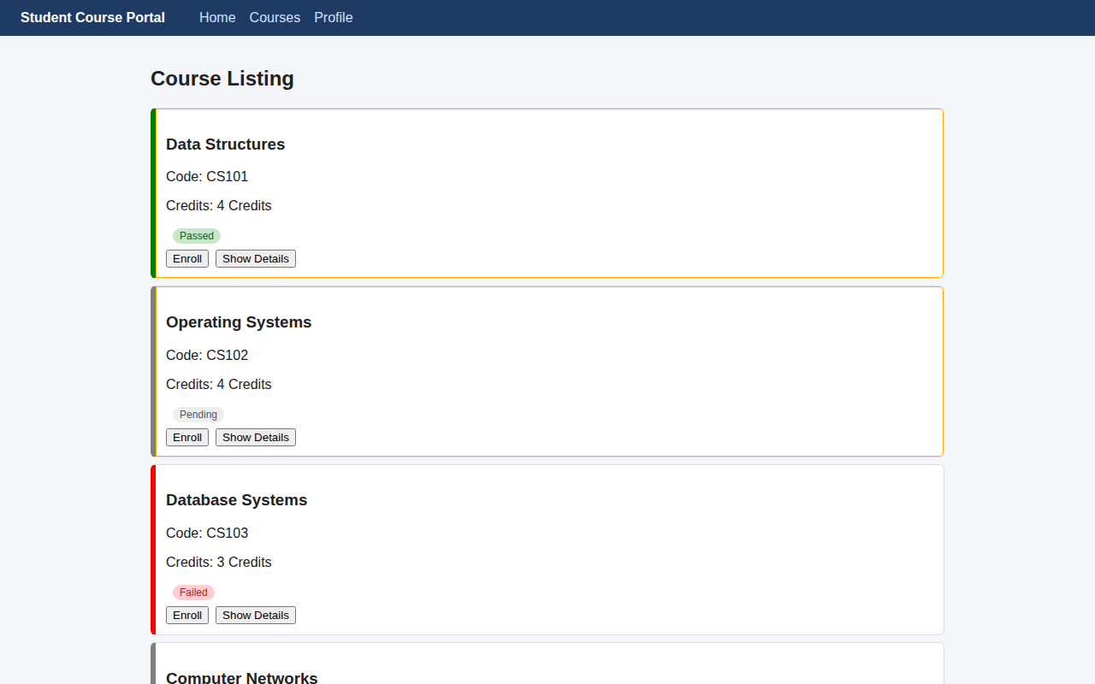

EXERCISE 4: Template-Driven Forms & Validation
CODE:
pages/enrollment-form/enrollment-form.component.ts:
import { Component } from '@angular/core';
import { CommonModule } from '@angular/common';
import { FormsModule, NgForm } from '@angular/forms';

@Component({
selector: 'app-enrollment-form',
standalone: true,
imports: [CommonModule, FormsModule],
templateUrl: './enrollment-form.component.html',
styleUrls: ['./enrollment-form.component.css'],
})
export class EnrollmentFormComponent {
studentName = '';
studentEmail = '';
courseId: number | null = null;
preferredSemester = 'Odd';
agreeToTerms = false;
submitted = false;

onSubmit(form: NgForm): void {
console.log(form.value, form.valid);
if (form.valid) this.submitted = true;
}
}

pages/enrollment-form/enrollment-form.component.html:
<h2>Enrollment Request (Template-Driven Form)</h2>
<form #enrollForm="ngForm" (ngSubmit)="onSubmit(enrollForm)">
<div class="field">
<label>Student Name</label>
<input name="studentName" [(ngModel)]="studentName" #nameCtrl="ngModel" required minlength="3" />
<span class="error" *ngIf="nameCtrl.touched && nameCtrl.errors?.['required']">Name is required</span>
<span class="error" *ngIf="nameCtrl.touched && nameCtrl.errors?.['minlength']">Name must be at least 3 characters</span>
</div>

<div class="field">
<label>Student Email</label>
<input type="email" name="studentEmail" [(ngModel)]="studentEmail" #emailCtrl="ngModel" required email />
<span class="error" *ngIf="emailCtrl.touched && emailCtrl.errors?.['required']">Email is required</span>
<span class="error" *ngIf="emailCtrl.touched && emailCtrl.errors?.['email']">Enter a valid email</span>
</div>

<div class="field">
<label>Course ID</label>
<input type="number" name="courseId" [(ngModel)]="courseId" #courseCtrl="ngModel" required />
<span class="error" *ngIf="courseCtrl.touched && courseCtrl.errors?.['required']">Course ID is required</span>
</div>

<div class="field">
<label>Preferred Semester</label>
<select name="preferredSemester" [(ngModel)]="preferredSemester">
<option value="Odd">Odd</option>
<option value="Even">Even</option>
</select>
</div>

<div class="field">
<label><input type="checkbox" name="agreeToTerms" [(ngModel)]="agreeToTerms" required /> I agree to the terms</label>
</div>

<button type="submit" [disabled]="enrollForm.invalid">Submit</button>
<button type="button" (click)="enrollForm.resetForm(); submitted = false">Reset</button>
<p class="success" *ngIf="submitted">Enrollment request submitted successfully!</p>
</form>

OUTPUT:
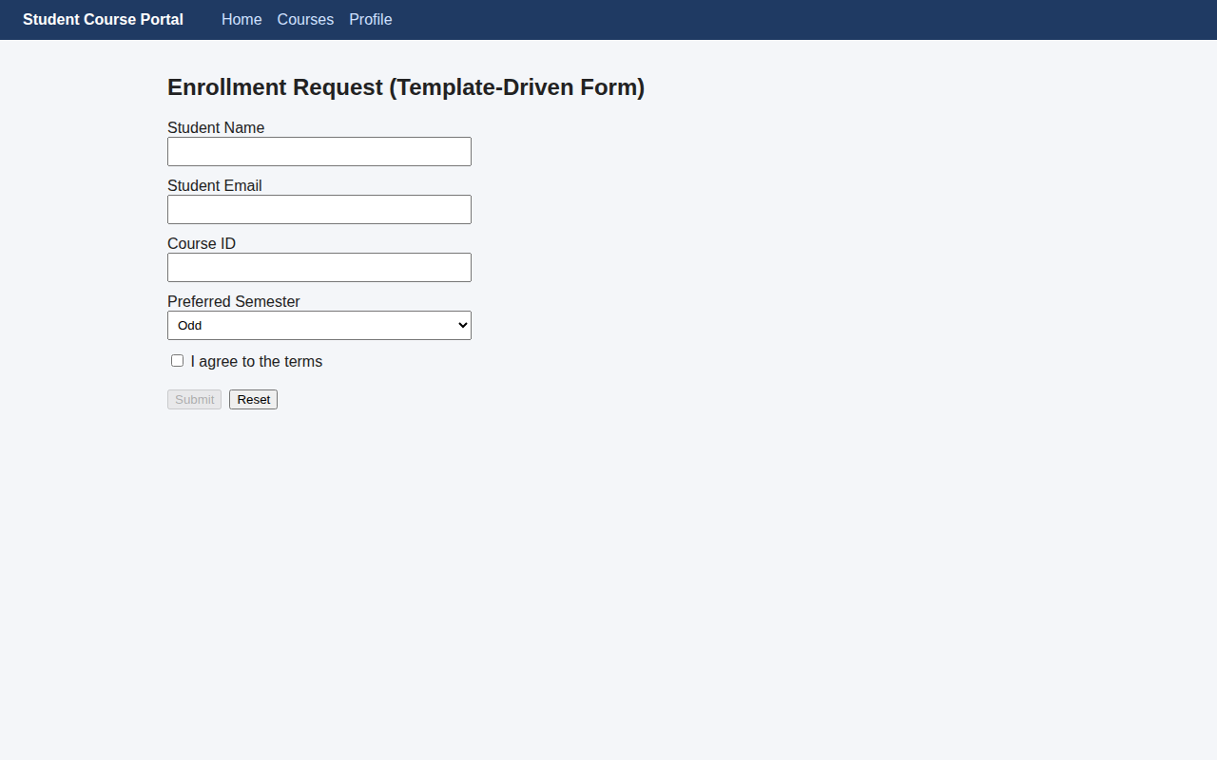

EXERCISE 5: Reactive Forms - FormBuilder, FormGroup, FormArray & Custom Validators
CODE:
pages/reactive-enrollment-form/reactive-enrollment-form.component.ts:
import { Component, OnInit } from '@angular/core';
import { CommonModule } from '@angular/common';
import {
AbstractControl, FormArray, FormBuilder, FormGroup, ReactiveFormsModule, ValidationErrors, Validators,
} from '@angular/forms';
export function noCourseCode(control: AbstractControl): ValidationErrors | null {
const value = control.value;
return value && String(value).startsWith('XX') ? { noCourseCode: true } : null;
}

export function simulateEmailCheck(control: AbstractControl): Promise<ValidationErrors | null> {
return new Promise((resolve) => {
setTimeout(() => {
resolve(String(control.value || '').includes('test@') ? { emailTaken: true } : null);
}, 800);
});
}

@Component({
selector: 'app-reactive-enrollment-form',
standalone: true,
imports: [CommonModule, ReactiveFormsModule],
templateUrl: './reactive-enrollment-form.component.html',
styleUrls: ['./reactive-enrollment-form.component.css'],
})
export class ReactiveEnrollmentFormComponent implements OnInit {
enrollForm!: FormGroup;
constructor(private fb: FormBuilder) {}

ngOnInit(): void {
this.enrollForm = this.fb.group({
studentName: ['', [Validators.required, Validators.minLength(3)]],
studentEmail: this.fb.control('', [Validators.required, Validators.email], [simulateEmailCheck]),
courseId: [null, [Validators.required, noCourseCode]],
preferredSemester: ['Odd', Validators.required],
agreeToTerms: [false, Validators.requiredTrue],
additionalCourses: this.fb.array([]),
});
}

get additionalCourses(): FormArray {
return this.enrollForm.get('additionalCourses') as FormArray;
}
addCourse(): void { this.additionalCourses.push(this.fb.control('', Validators.required)); }
removeCourse(index: number): void { this.additionalCourses.removeAt(index); }

onSubmit(): void {
console.log('value:', this.enrollForm.value);
console.log('getRawValue:', this.enrollForm.getRawValue());
}

isDirty(): boolean { return this.enrollForm.dirty; }
}

pages/reactive-enrollment-form/reactive-enrollment-form.component.html:
<h2>Enrollment Request (Reactive Form)</h2>
<form [formGroup]="enrollForm" (ngSubmit)="onSubmit()">
<div class="field">
<label>Student Name</label>
<input formControlName="studentName" />
<span class="error" *ngIf="enrollForm.get('studentName')?.touched && enrollForm.get('studentName')?.errors?.['required']">Name is required</span>
<span class="error" *ngIf="enrollForm.get('studentName')?.touched && enrollForm.get('studentName')?.errors?.['minlength']">At least 3 characters</span>
</div>
<div class="field">
<label>Student Email</label>
<input formControlName="studentEmail" />
<span class="error" *ngIf="enrollForm.get('studentEmail')?.errors?.['emailTaken']">Email already taken</span>
</div>
<div class="field">
<label>Course ID</label>
<input formControlName="courseId" />
<span class="error" *ngIf="enrollForm.get('courseId')?.errors?.['noCourseCode']">Course code starting with XX is not allowed.</span>
</div>
<div class="field">
<label>Preferred Semester</label>
<select formControlName="preferredSemester">
<option value="Odd">Odd</option>
<option value="Even">Even</option>
</select>
</div>
<div class="field"><label><input type="checkbox" formControlName="agreeToTerms" /> I agree to the terms</label></div>
<div class="field" formArrayName="additionalCourses">
<label>Additional Courses</label>
<div *ngFor="let ctrl of additionalCourses.controls; let i = index">
<input [formControl]="$any(ctrl)" />
<button type="button" (click)="removeCourse(i)">Remove</button>
</div>
<button type="button" (click)="addCourse()">Add Another Course</button>
</div>
<button type="submit" [disabled]="enrollForm.invalid">Submit</button>
</form>

OUTPUT:
